# CS 255 System Design Document Template

Kilroy, Robert R.

This template lays out all the different sections that you need to complete for Project Two. Each section has guidance to prompt your thinking. You will need to continually reference the interview transcript as you work to make sure that you are addressing your client’s needs. There is no required length for the final document. Instead the goal is to complete each section based on what your client’s needs are. Remove this note when you are finished, and replace all bracketed text with the relevant information.

## UML Diagrams

### UML Use Case Diagram

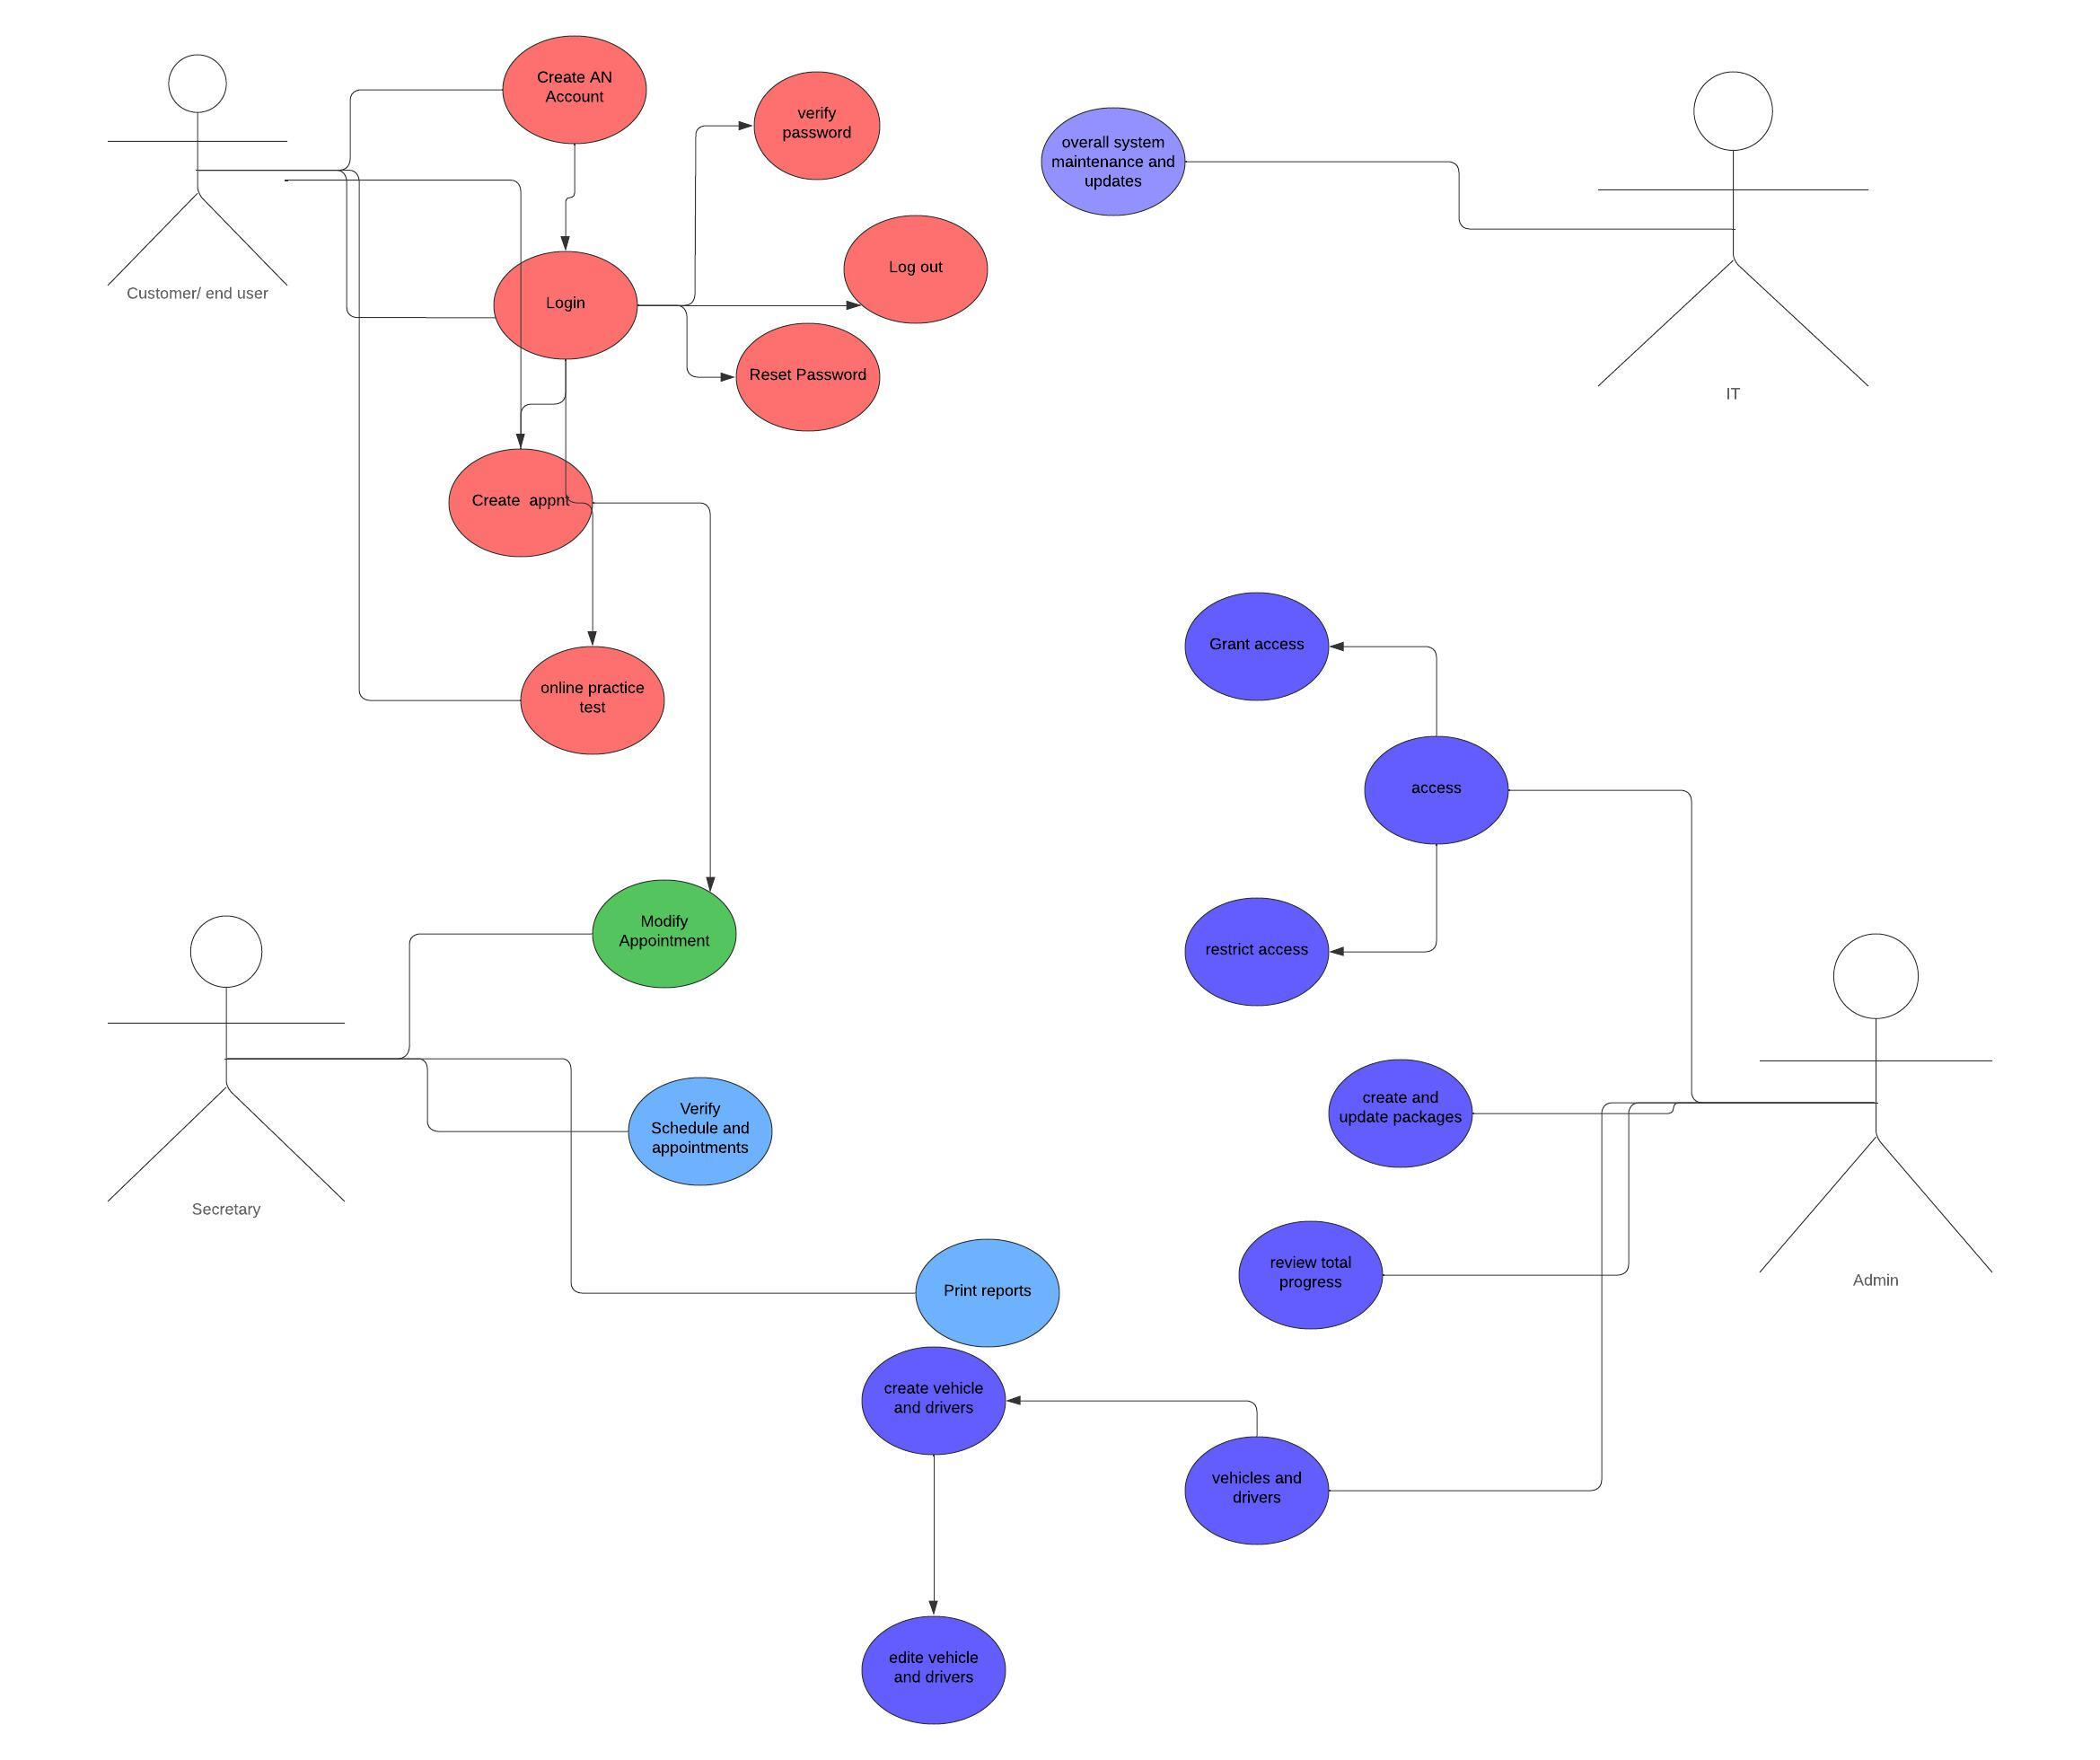

### UML Activity Diagrams

### UML Sequence Diagram

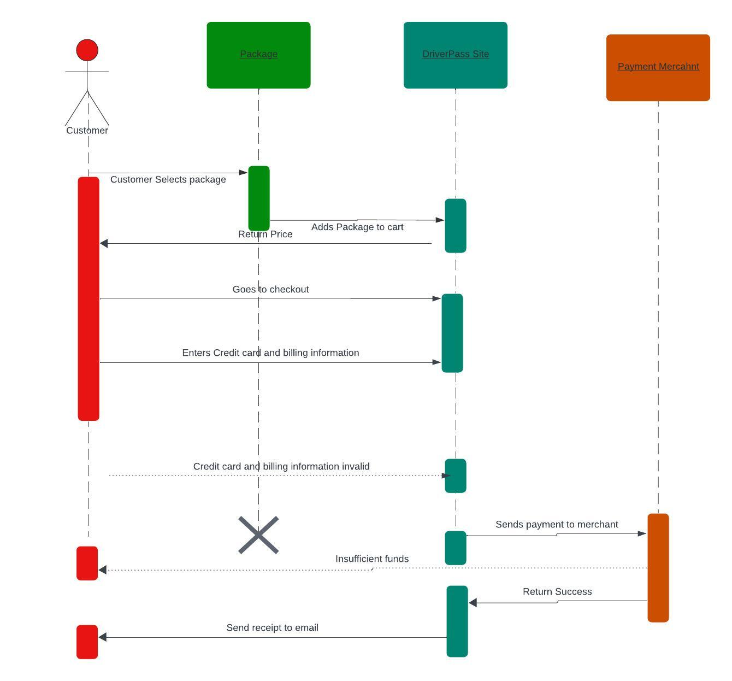

### UML Class Diagram

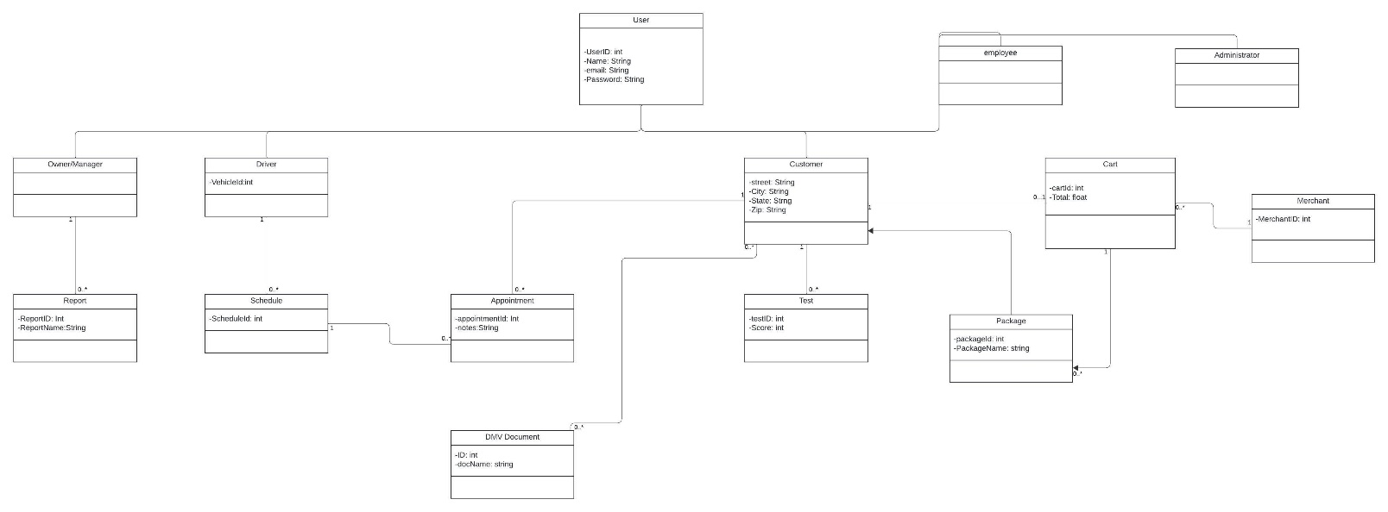

## Technical Requirements

* Software
  + Most stable Windows Server
  + Most Stable SQL server to store the database
  + Backups for both the website and the database
  + Antivirus/malware protection
* Geographic Information
  + Accessible in America
  + Servers secured in the data center
  + Servers in a centralized location
* Hardware
  + Dedicated server
  + Internet connection
  + Storage for both database and website
  + Device to access the website whether that would be a PC or mobile device
  + Firewall to protect ports